附件：
引自“医科研”公众号

暴雷啦！35本杂志被踢出SCI索引，Frontier 被引入示警名单
3月20日，科睿唯安官方发布了2023年最新的SCI目录，目前共有SCIE期刊9509本，其中有35本期刊突然被剔除。包括影响因子高达7.31的Oxidative Medicine and Cellular Longevity和很多科研硕博耳熟能详的Journal of Oncology，大家在之后的投稿中，需要注意：
1.Advances m Materials Science and Engineering 2.098
2. Annals of Palliative Medicine 1.925
3. Annals of Translational Medicine 3.616
4. Applied Nanoscience 3.869
5. Biomed Research inteimational 3.246
6. Computational and Mathematical Methods 2.809
7. Neuroscience Computational intelligence and 3.120
8.Concurrent Engineering-Research and 2.118
9. Contrast Media & Molecular Imaging 3.009
10. Disease Markers 3.464
11. Evidence-Based Complementary and Alternative Medicine 2.650
12. Food Science and Technology 2.602
13.Fresenius Environmental Bulletin 0.618
14. International Journal of Environmental Research and Public Health 4.614
15. Journal of Coastal Research 1.110
16. Journal of Environmental and Public Health 2.791
17. Ecology Journal of Environmental Protection and Ecology 0.507
18. Journal of Healthcare Engineering 3.822
19. Journal of Nanomaterials 3.791
20. Journal of Oncology 4.501
21. Journal of Renewable Materials 2.115
22. Agronomy Journal of The American Society of AGRONOMY
23. Mathematical Problems in Engineering 1.430
24. Mobile information Systems 1.863
25. Netherlands Journal of Medicine 1.105
26. Ochrona Srodowiska
27. Oxidative Medicine and Cellular Longevity 7.310
28. Progress in Nutrition 0.567
29. Psychiatria Danubina 2.696
30. Revista Brasileira De Medicina Do Esporte 0.652
31. Scanning 1.750
32. Scientific Programming 1.672
33. Security and Communication Networks 1.968
34. Waves in Random and Complex Media 4.051
35. Wireless Communications &Mobile 2.146

以上剔除名单中，Hindawi有多达18本，很多期刊都是之前被科睿唯安设定为关注期刊（On hold）,而如今最终被剔除。和Hindawi同为知名OA出版社的Frontiers可能也要密切关注，因为其旗下的Frontiers in psychology目前也已经处于On hold状态！

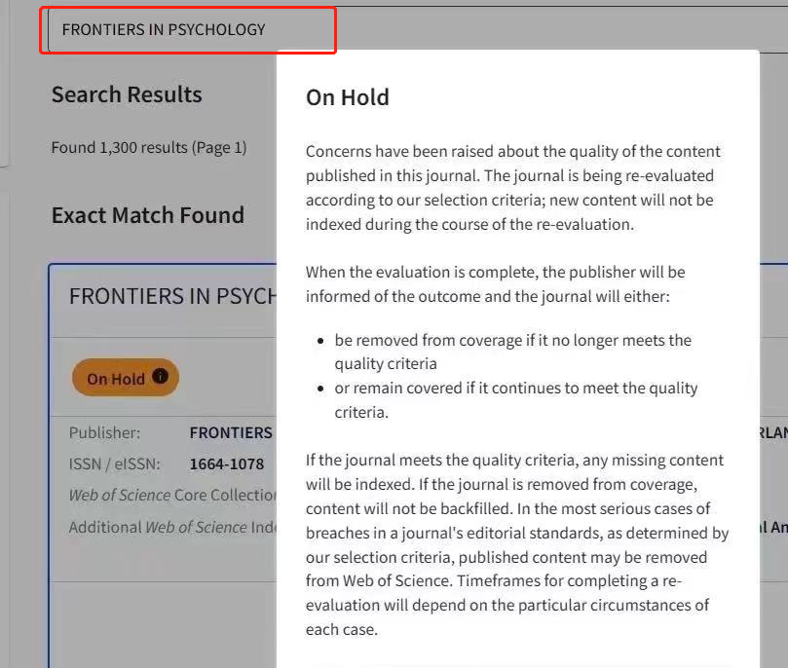
由上可见，科睿唯安数据库已经密切关注到各大期刊的学术诚信问题，如果这些期刊继续再不改变目前的运营策略，将会有进一步动作。
以上剔除期刊，今年6月份估计也不会有影响因子，后续投稿大家需要注意甄别。

